**CRF ID-117270 MODIFICATION OF RM RHA AM SECURITY SHORTAGE REPORT**

**WORKFLOW**

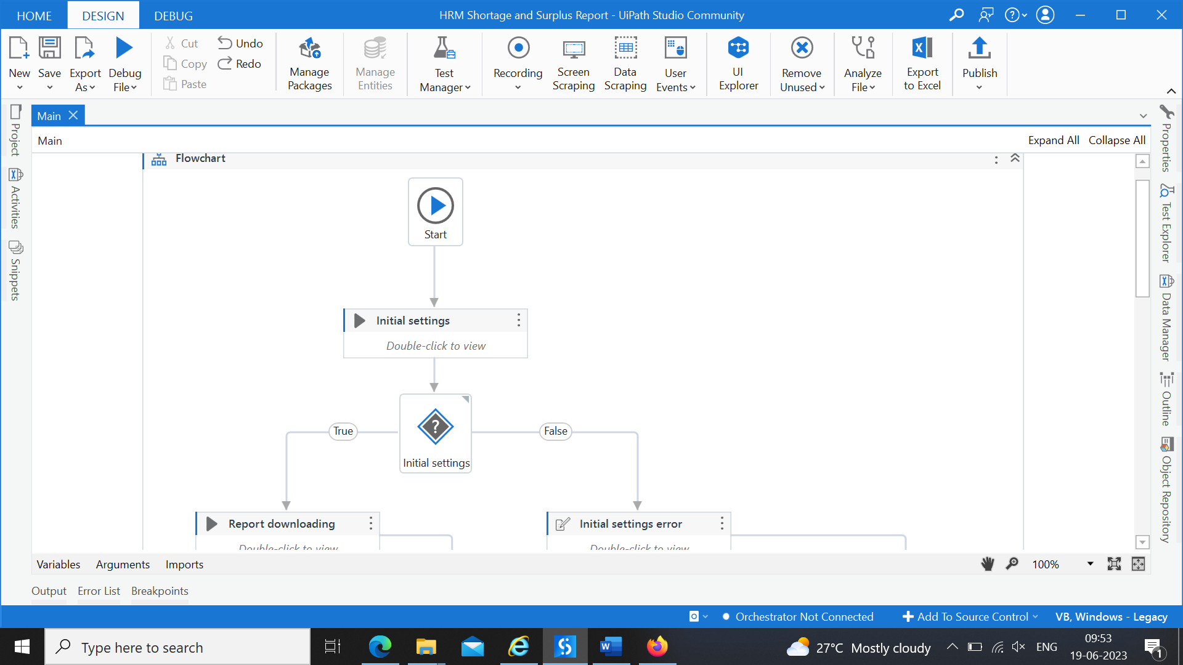

**REPORT DOWNLOADING USING QUERY**

**REGIONAL MANAGER**

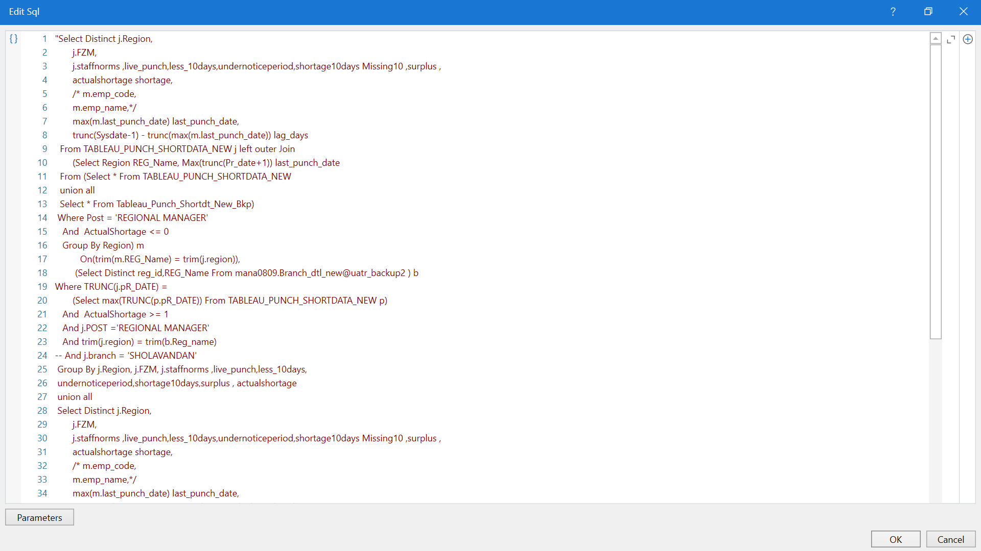

**REGIONAL HEAD(AUDIT)**

**ARM/AM – SECURITY**

**AH REPORT**

**INTERNAL AUDITOR**

**REPORT**

**REGIONAL MANAGER**

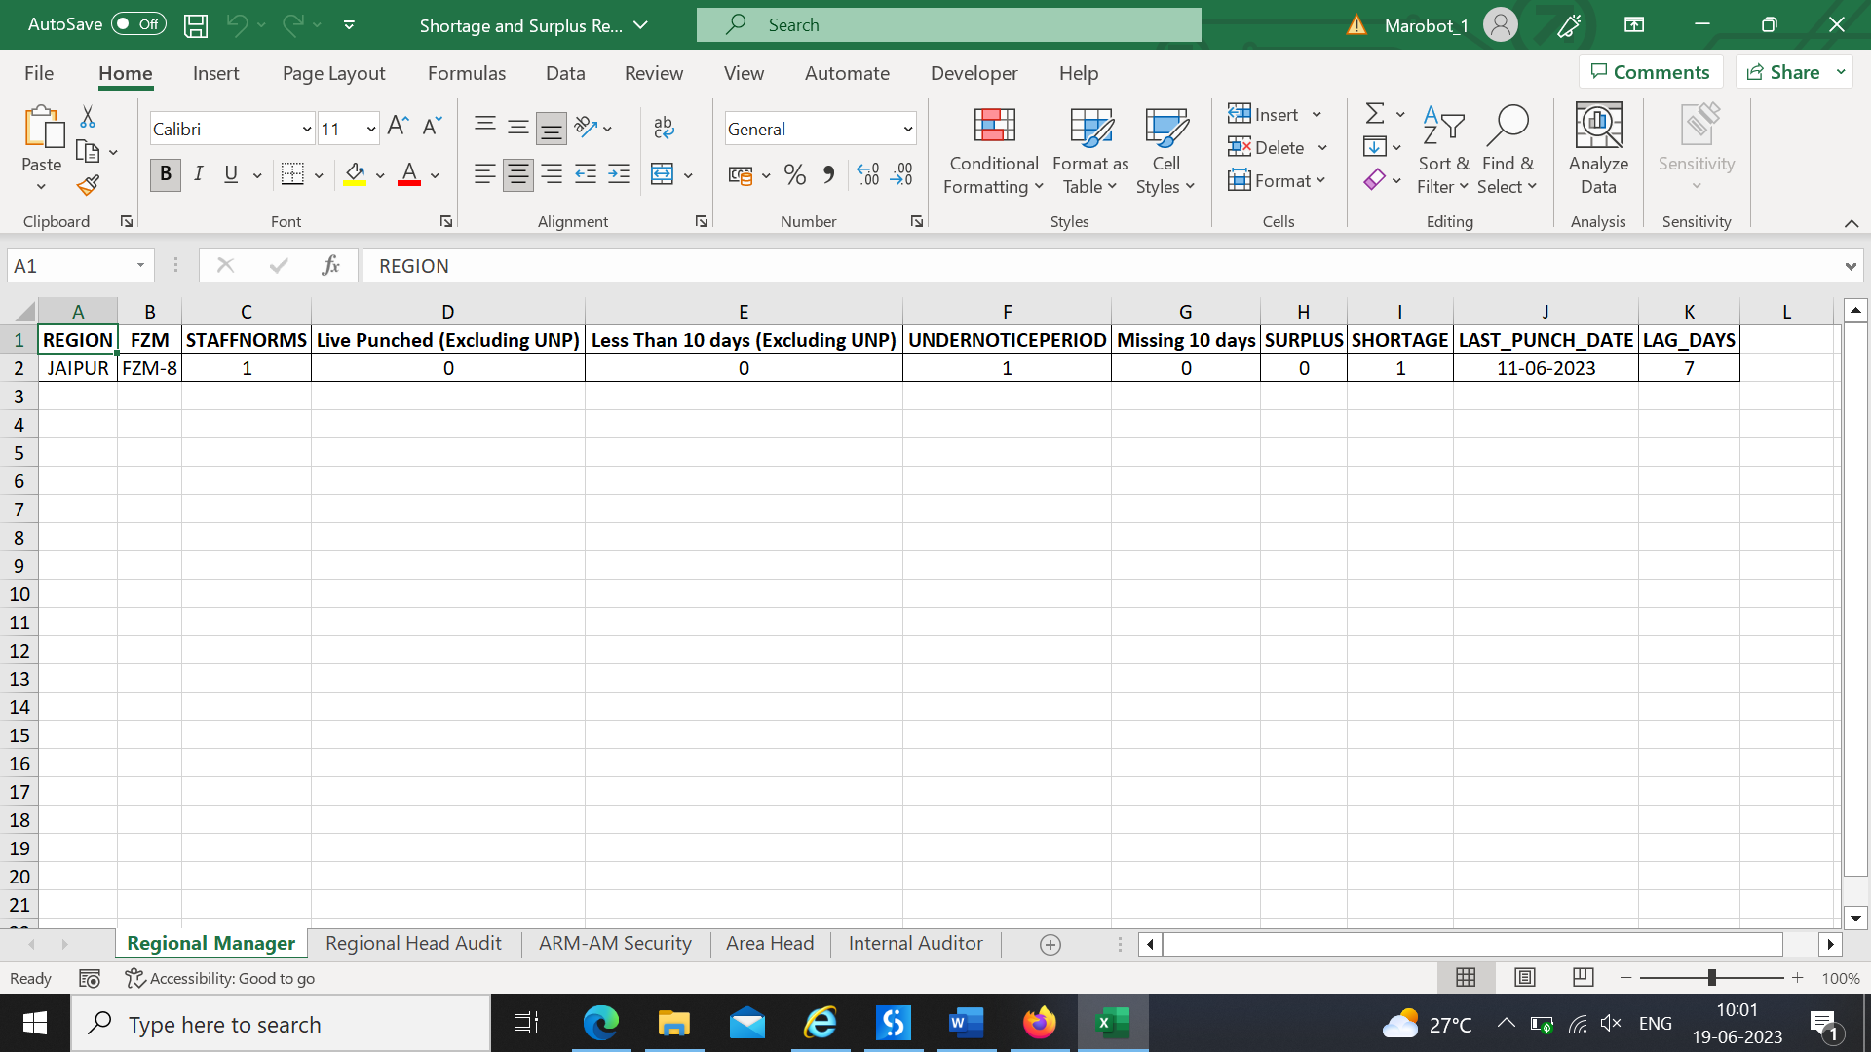

**REGIONAL HEAD AUDIT**

**ARM-AM SECURITY**

**AREA HEAD**

**INTERNAL AUDITOR**

**MAIL**

